AMPWHS201
Sharpen and handle knives safely
Training and assessment support materials

Acknowledgement
These training materials were produced by MINTRAC as part of a Skills Insight Jobs and Skills Council (JSC) project, and as part of their collaborative partnership with Skills Insight. MINTRAC has a strong history working with the Australian meat processing industry on skills and training solutions and were engaged by Skills Insight to deliver this project in partnership.
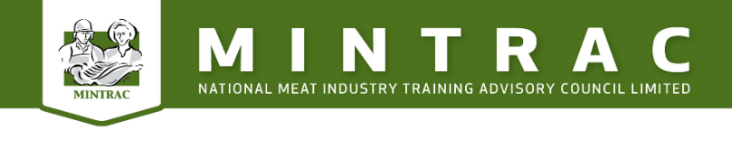
IP information
Skills Insight has sublicensed MINTRAC as the authorised distributor of these training materials. They are distributed free of charge and those who download them will be notified of any future updates.
These materials cannot be revised or adjusted without seeking written permission from Skills Insight JSC.
These materials are created through funding by the Australian Government.
Copyright in this material vests in the Australian Department of Employment and Workplace Relations (DEWR).
Disclaimer
The views expressed in this work do not necessarily represent the views of DEWR. In addition, DEWR does not give warranty or accept any legal liability in relation to the content of this work.


Skills Insight is a Jobs and Skills Council funded by the Australian Government Department of Employment and Workplace Relations.
For further information about these Training Materials or any other work being undertaken by Skills Insight, please visit: www.skillsinsight.com.au
© Australian Government Department of Employment and Workplace Relations, 2024.

Table of contents
Training support materials for AMPWHS201 – Sharpen and handle knives safely 4
What must be considered when choosing a knife? 4
What are the parts of a knife? 5
How is the knife maintained in good order? 5
How is sharpening equipment prepared and maintained? 6
What are the WHS issues with knives? 6
How and where do you store your knife while you are working? 8
How do you attach the steel and scabbard? 8
Bibliography 10
Additional resources 10

Training support materials for AMPWHS201 – Sharpen and handle knives safely

What must be considered when choosing a knife?
When you are choosing a knife, the following factors are important:
- stainless steel blade
- thickness of the blade
- length of the blade and of the knife
- shape of the blade
- type of handle.
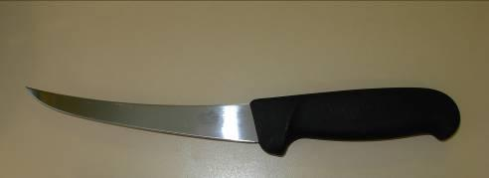 | 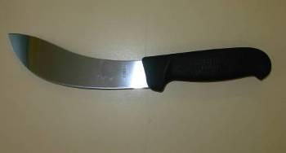
Boning knife Skinning knife
Picture courtesy T&R Murray Bridge South Australia

In general, a broader, heavier blade is better for most slaughter purposes, such as skinning, and a thinner, flexible blade is better for boning and slicing. Most knives have blades between 125 to 175 millimetres long. Shorter blades, when sharp, require less force to cut and may reduce repetitive strain injuries.
Knives have a shaped plastic to prevent ‘run through’ cuts if the hand slips onto the blade.
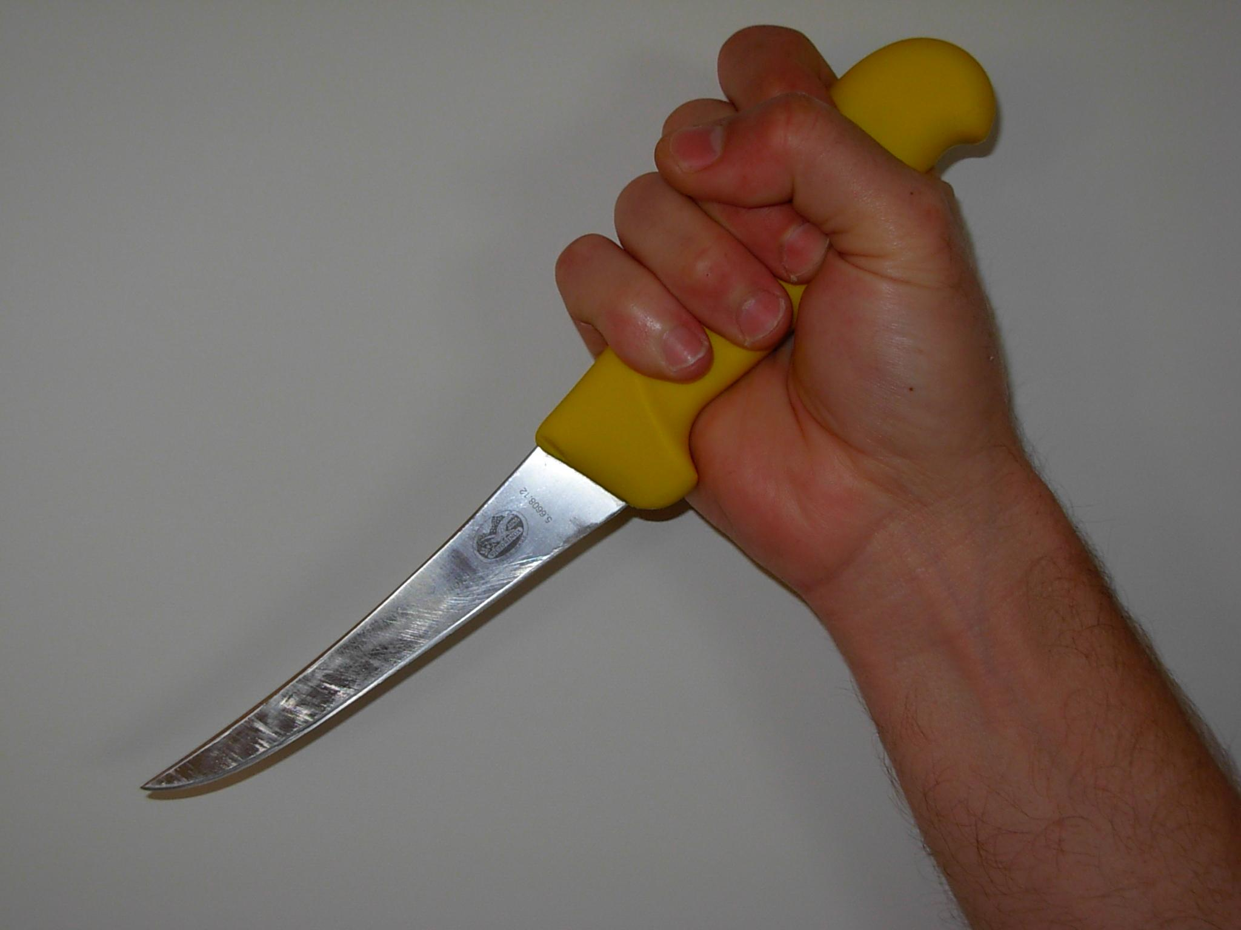
A typical boning grip. The choice of knife is dependent on its use.
Picture courtesy T&R Murray Bridge South Australia

What are the parts of a knife?
There are two sections to a knife – the handle and the cutting blade.
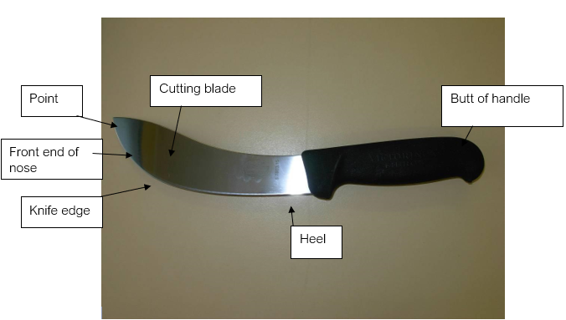
Parts of a knife
Picture courtesy T&R Murray Bridge South Australia

The handle
The shape of the handle needs to be comfortable for you to grip. It must also provide some safety for you, as the heel of the handle prevents your hand from slipping over the blade or the blade coming back through your hand (commonly known as a ‘knife slip’).
Plastic-handled knives are easier to clean. However, they can be a safety hazard if fat builds up on the handle, because this can increase the chance of your hand slipping. You need to clean your knives regularly to prevent this from happening. Knife handles used in slaughtering premises are made from a slip resistant surface, but they still require regular cleaning. W

The blade
Different parts of the blade have different names, as shown below.
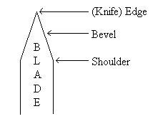
Cross section of a blade
© MINTRAC

How is the knife maintained in good order?
Your knife must be kept sharp at all times. This will reduce the risk of an accident and ensure more efficient use and reduce repetitive strain injuries. Grinding stones, oilstones and machine sharpening are used to sharpen the blade, eliminate the shoulder and achieve the most efficient blade bevel.
You must use your knives skilfully and safely.
Before the knife edge can be sharpened, you must decide what shape the blade is to be. This depends on its shoulder and bevel. The thicker the shoulder, the greater the angle of the bevel. Thicker shoulders are useful when cutting around bones or thick wool as they minimise the edge being ‘rolled over’, which would then require steeling. A rough steel may be required to straighten the edge after contact with bones / thick wool or the like.
If the blade is too thick or has large shoulders, the edge will quickly become dull and will not cut easily.

The bevel
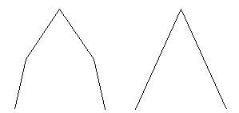
Thick shoulder Blade too thick
© MINTRAC
The bevel is the pointed part of the blade and can be a different shape on different knives. There are different shapes of bevel because:
- different tasks need different shapes, e.g. boning, slaughtering
- types of steel vary – hard or soft
- shape of blades varies.
The bevel is shown by the darker lines on the following diagram.
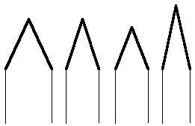
Different bevels on knives
© MINTRAC
The bevel should be about 1 millimetre wide. Both sides of the blade should have an even bevelled surface at an angle of 15–25 degrees. The two bevels must meet precisely along the full length of the blade. This can be difficult along the curved part of the blade. During the sweeping motion of sharpening, the knife handle will need to be lifted slightly to allow the bevel to continue down the curved blade. The use of a black marker to mark the bevel will enable the user to see where the metal is coming off the knife and enable the bevel to be even the full length of the blade.
The bevel is different for each type of work. For example, boning knives frequently come in contact with bone. A fine bevel will often result in large chips in the cutting edge, so a thicker bevel is best. Slicing or skinning knives need a fine bevel or hollow grinding to remove resistance or pressure needed to cut.

The knife edge
The knife edge is the point where these two bevelled edges meet. The edge will be very thin if both the shoulder and the bevel have been maintained correctly. This can result in the edge turning over and forming a 'lip' or 'feather'. You must take this lip or feather off or the edge will double or sometimes treble in thickness. It will then not cut cleanly.
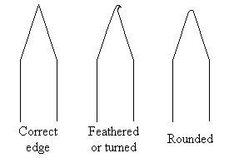
Types of edges
© MINTRAC

The grindstone
You should use a grindstone to thin the shoulder of the knife to the desired shape, as shown in the following diagram. A sandstone or emery wheel may also be used for this purpose.

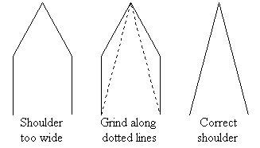
Types of shoulders on blades
© MINTRAC
When operating the grindstone, you should use enough water, so it prevents damage to the knife and stone. The wheel should turn away from you and the knife edge should be facing away from you. You must not let the knife face towards you, as it can dig into the grindstone, twist rapidly and cut into your hand (knife roll).
Untrained workers should seek assistance from a supervisor or training officer.
Sometimes different edges are required for different animals to prevent damage to the knife. Often ‘lot fed’ cattle have hides with a build-up of mud and faeces. Cutting through this, especially the leggers and flankers, will quickly blunt a sharp knife. You will often be better off with a thicker bevel and rough steel reserved for this task.
To get a good, flat, cutting bevelled edge, you must press firmly on the blade. Avoid placing fingers on the blade. Repeat the process on both sides until both sides are the same. The knife is now ready to be honed.
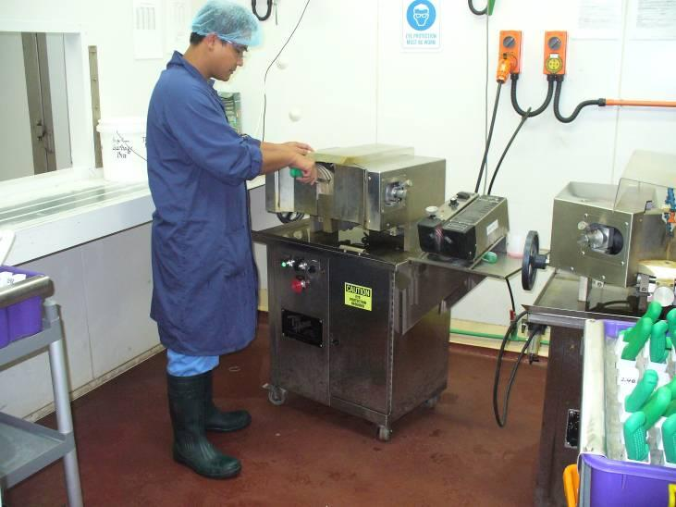
Knife sharpening machine
Photo courtesy Fletcher International WA

Hollow grinding
Hollow grinding is when you need a fine very sharp edge. This type of edge is not recommended where the knife is likely to contact bone or hard table surfaces; but it is recommended for slicing (using cutting boards), skinning and inspection tasks. Both sides of the blade are ground to produce a slight hollow usually about 7 mm wide and finishing about 1mm from the edge of the blade. Don’t grind right down to the edge or you will have a ‘feather’ edge and that defeats the purpose.
The main advantage of hollow grinding is the ability to quickly sharpen the edge by placing the blade flat on the stone, so the blade edge of the hollow is being sharpened; it also reduces knife drag, reducing effort and wear and tear on your wrists. Take care not to overuse the whetstone or you could produce a feather edge. You’ll know if you have as fine bits of the edge will come off as you steel the knife. Always check for this before you go near the product again.
Grind should leave 1mm of blade untouched both sides at the edge.
Hollow should be about 7mm wide

Belt grinders
Belt grinders are the choice of most modern meat slaughtering premises. They are a versatile tool that can be used for flat grinding, hollow grinding and reshaping the knife.
Two important things to remember are safety and pressure
.
- Safety – always use eye protection, the belt should be firmly attached, not tight and rotate away from the body.
- Pressure – keep it light to prevent heat, excessive heat will burn the steel and make it brittle. Always have a water container handy and regularly cool the blade. When flat grinding hold the blade flat and just lifted up so the back of the blade is 1mm clear of the belt. The back of the blade is where the strength is so don’t grind it off.

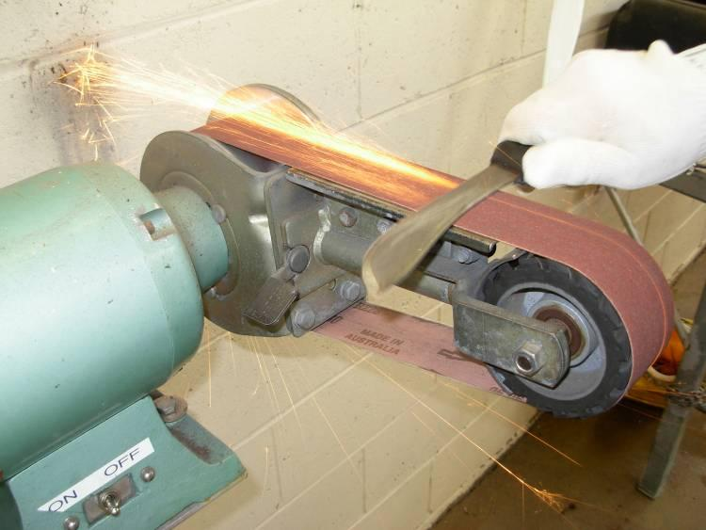
Allow 1mm between the belt and the back of the blade. Light pressure, patience and keep the blade cool.
Hollow grinding can be done on the curved part of the belt. Take care not to grind right down to the cutting edge. Finish the grind leaving a 1mm cutting edge to finish on the oilstone.
Belt Grinder
Picture courtesy T&R Murray Bridge South Australia

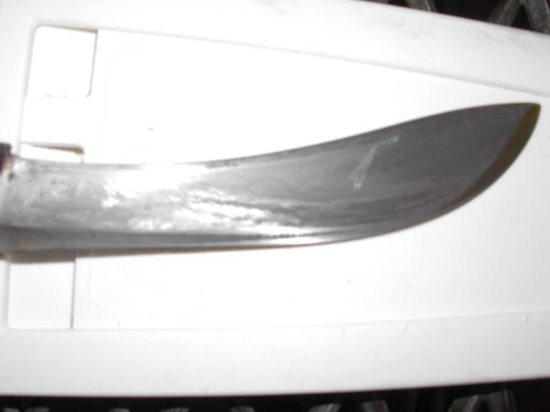
Thick shoulder
Blade prior to grinding note the thick shoulder
Picture courtesy T&R Murray Bridge South Australia

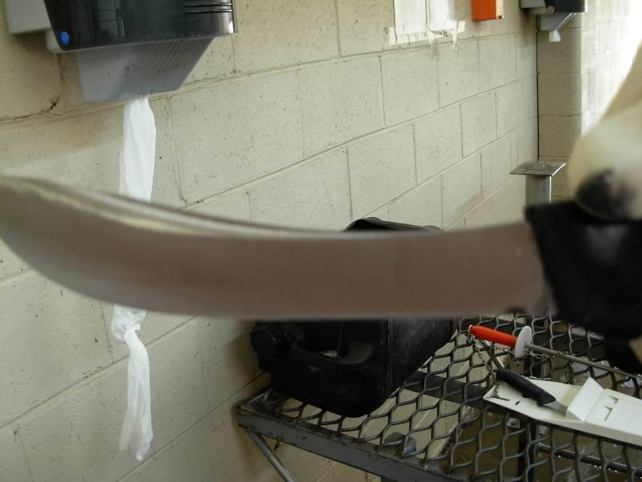
Finished flat ground blade – note the shoulder is completely gone.
Picture courtesy T&R Murray Bridge South Australia
At this point you can decide whether or not you wish to hollow grind the blade. If you do decide, you can use the belt sander or a hollow grinding machine.

Hollow grinding machines
These machines have two opposing wheels set at whatever grinding setting you require. They can be set extremely close for a fine cutting edge and small hollow or wide for thick knives that need a bigger hollow. Again, let the machine do the work, don’t force the blade through, just guide it. The machine will have cooling water or water and oil to prevent burning. Always wear your eye protection!!! And also wear your hair cover as your hair could get caught in the wheels.
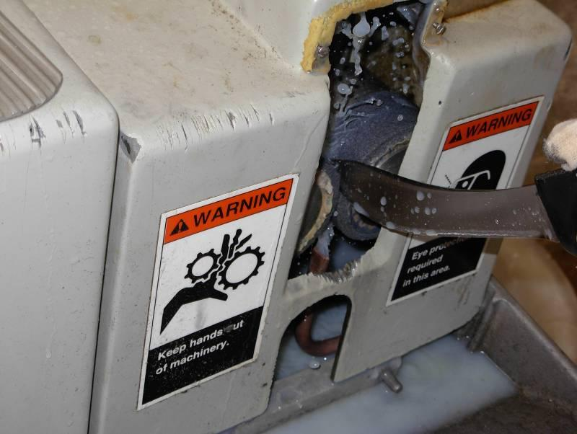
Cutting the hollow
Hollow grinding machine
Picture courtesy T&R Murray Bridge South Australia
In this picture you can see the gap setting is at its widest - you could hollow grind a cleaver with this setting.
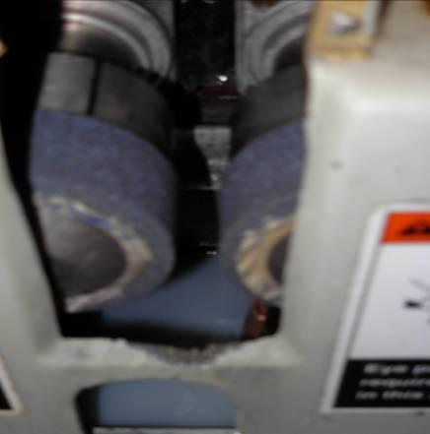
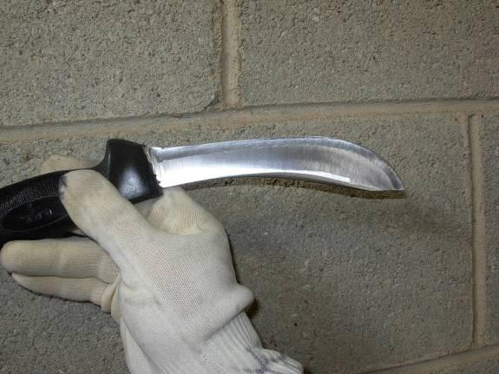
7mm hollow
A perfectly hollow ground knife
Pictures courtesy T&R Murray Bridge South Australia

The Oilstone
Man-made oilstones are made from silicon carbide and aluminium oxide. The abrasive grit is pressed and heated like a ceramic to a high temperature until it is effectively a stone. These materials cut faster than the natural stones but require a lighter touch to achieve the same results.
You can use an oilstone or whetstone to shape or bevel the sides of the knife blade which forms the edge. This process is called honing the blade.
A larger two-layer oilstone is the easiest to use. One side should be a medium coarse abrasive and the other side medium fine.
Honing oil, (white oil is a good choice) as well as water and detergent, are used on the oilstone to stop the stone from clogging up with small pieces of metal from the knife. Do not use lubricating oils for honing as they form a sludge which makes it difficult to cut the metal of the blade. They also tend to clog the porous feature of stones.
A stone clogged with sludge or fat will appear glossy and be of little use to you.
Hot water and a strong detergent will get it out. Do not use the caustic in the hook shed to clean stones as it is extremely dangerous and against company safety rules. Caustic reacts with moisture and fat to create heat. If it comes into contact with you, it’ll burn a hole in your skin.
- Place the stone on a clean surface or stainless-steel frame (stone holder) to eliminate cross-contamination. Use a clean piece of towelling to prevent the stone slipping.
- A fixed stone holder is the safest and best way to secure the stone.
- Clean the knife before sharpening.
- Clean the stone after each use to remove fat build-up. (If hot water will not remove fat build up contact maintenance to dip in acid wash with the rollers) This will add ‘bite’ to your stone.
- Store the stone in a clean area.
When honing, the blade should be drawn across the oilstone from the heel to the point, as shown in the following diagram. You must keep the knife at the same angle that it was ground on the grinding stone. Do one side and then the other, in that order, or an uneven blade will occur.

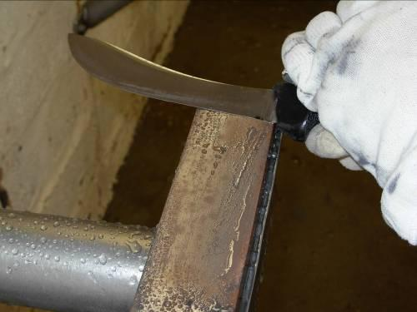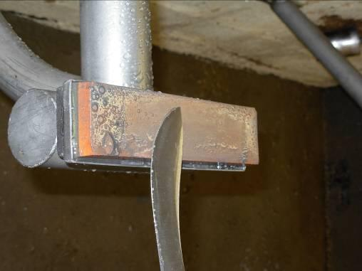
Knives sharpened on the oilstone
Pictures courtesy T&R Murray Bridge South Australia
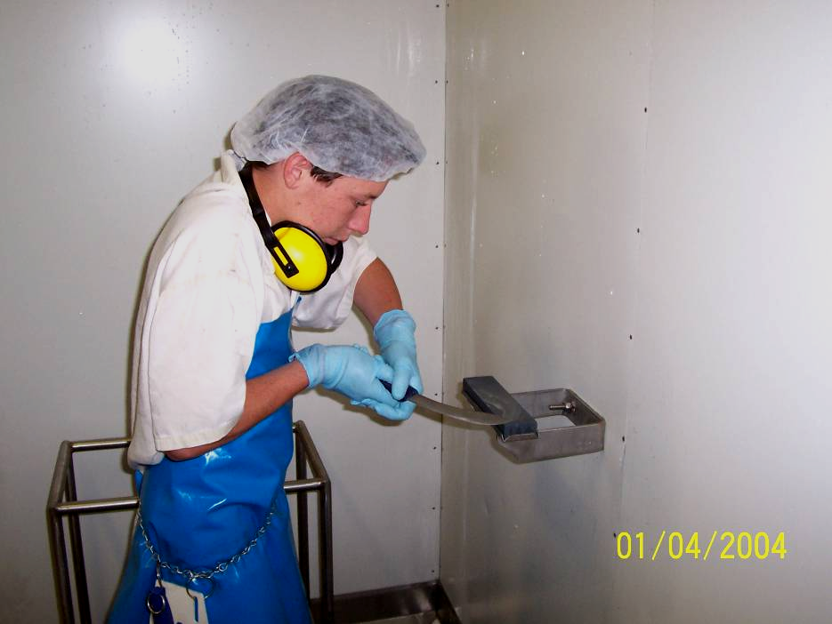
Notice the lifting motion without changing the bevel angle to obtain a sharp edge on a curved blade.
Photo courtesy Goulburn Ovens Institute of TAFE
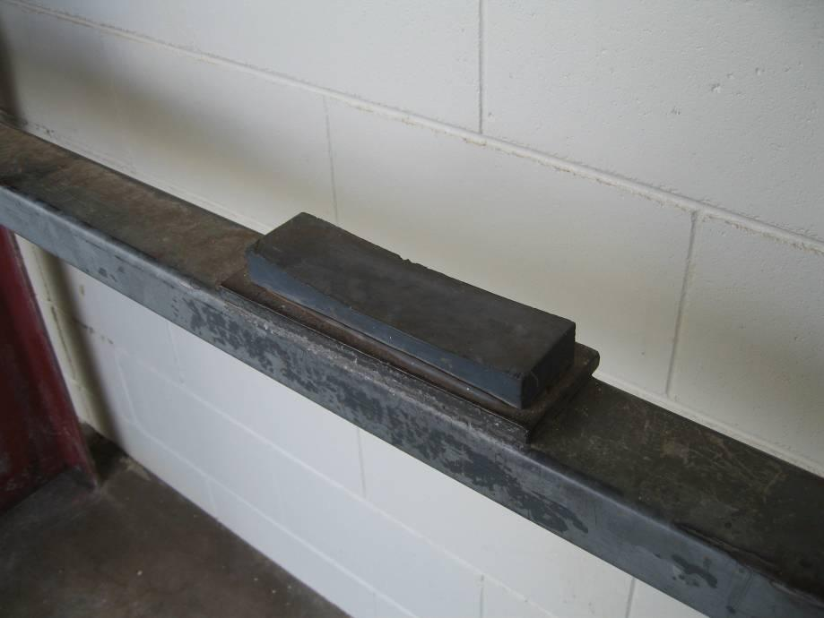
Sharpening stone
Photo courtesy Fletcher International © MINTRAC
Ensure that the blade is evenly sharpened on both sides. The knife is now ready to be steeled.

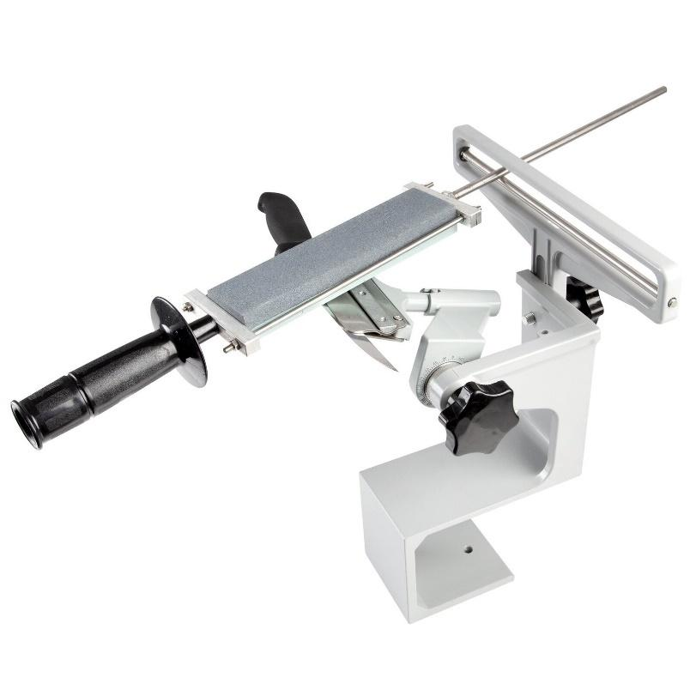
EZESharp Knife Sharpener
Sharpening knives using a jig such as the EZESharp knife sharpener is becoming increasingly popular because:
- it holds the stone at a set angle
- is easy to learn
- gives a consistent result.

In fact, some companies are now setting these jig sharpeners up at premises enables knife hands to easily sharpen their knives.

Jig systems vary in price and complexity, but they all involve holding the knife in a fixed position and then moving the sharpening stone backward and forward across the knife edge. The blade is then turned over and the other side of the edge sharpened.

Most jigs come with instruction manuals and videos. MINTRAC has a range of videos that demonstrate how to sharpen knives.

The steel
The steel is used to straighten the edge of the knife. It does not sharpen it. It finishes off and maintains the edge that you achieved by using the grindstone and oilstone.
There are many different types of steels, such as:
smooth – honing should be done with a smooth steel to make as fine an edge as possible
- mild – used to straighten rolled over edges. For best results complete honing back onto smooth steel before recommencement
- coarse – mainly used for straightening severely bent or rolled over edges from cutting into bones or through thick wool and the like. For best results complete honing back onto smooth steel before recommencing work.
- diamond impregnated - the diamond particles are of a particular shape to ensure optimal honing of the edge, and the steel surface is coated with diamond granules
- wire-styled steel – similar to a smooth steel with set angles to pull the knife through.
When using the steel, lightly stroke the knife a few times each side is all it should take on a smooth sharpening steel to restore the shaving edge each time it dulls. This is done by placing the heel of the blade on the steel and lightly drawing the blade down across the steel at the same angle as the bevel. You should always use the same number of strokes on each side of the blade.
A bad habit many workers develop is to beat the knife on the steel, often resulting in chipped blades. The end of the steel is magnetised – this is all the contact pressure you need. Get into the habit of guiding the blade down the steel gently and slowly’. A steel is only intended to straighten or restore the cutting edge, not grind or sharpen the knife- that’s what the sharpening stone does!
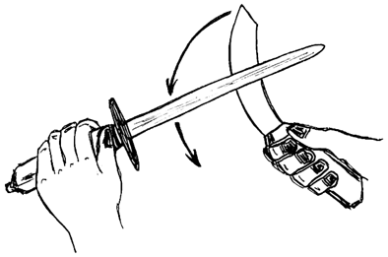
Thumb on same side as fingers - cut resistant gloves are also recommended
© MINTRAC

After using the steel, you should sterilise the knife. If the edge on the knife has been ‘rolled over’ the use of a rough steel maybe required to straighten the edge prior to using a smooth steel. The rough steel has more bite than a smooth and hence straightens a rolled blade more easily and quickly.
The knife is then ready for use. For safety most employers insist on an aftermarket hand protector fitted to the shaft of the steel. They are mostly made of a rounded piece of cutting board with a hole in the middle; it slides down the shaft to the handle. They are essential for protecting your thumb against cuts whilst steeling. Always watch what you are doing when steeling. Don’t become complacent.
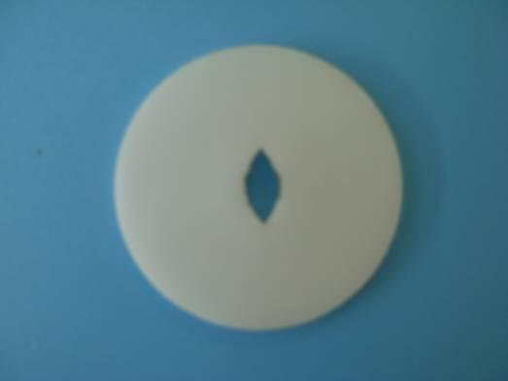 | 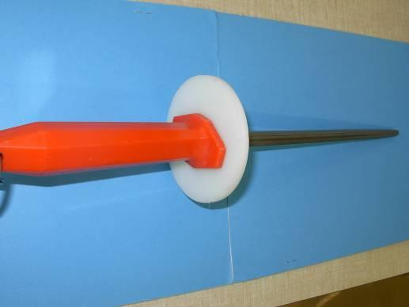
Hand guards
Pictures courtesy T&R Murray Bridge South Australia

How is sharpening equipment prepared and maintained?
To maintain a good surface on your steel and protect it from becoming a source of contamination, make sure you scrub your steel thoroughly in hot soapy water, then dry it, at the end of production every day. You may also like to coat your steel with vegetable oil at the end of each day.
Every day before you use your steel and wherever required by your workplace procedures, sterilise it in the steriliser.
Other sharpening equipment such as grindstones and oilstones or whetstones, must also be prepared and maintained in good working order.

Grindstones / sandstones
Make sure that there is a continual supply of water on the sandstone when it is in use. It keeps the stone clean and the blade cool.
Check there are no chips or pieces missing from the stone as this can be a safety hazard and can damage your knife when grinding. Also look for hard lumps in the sandstone; they can cause the knife to be bounced off the wheel. Lumps or bumps will require wheel maintenance (cutting down the surface).
Maintain the machine bearing to ensure smooth turning and shape of the stone.
High speed grinders are good as long as they are operated properly. Safety is the major concern, so get an expert to demonstrate its use. Heat is the next major concern - the blade must be kept cool. Don’t be tempted to press hard for a quick result. Be patient because if the blade overheats (goes dark or blue) your knife edge is ruined. It will become brittle, chip easily and require all the damaged steel to be carefully removed. Most people find it easier to buy a new knife and start again.

Oilstone (whetstone)
You must clean the oilstone regularly with soap and water and also sterilise it. This will help to prevent micro-organisms building up and will maintain a better surface for honing.
Oilstones should be stored correctly to make sure they don't get contaminated, damaged or stolen.

What are the WHS issues with knives?
Knives are important tools in the meat industry. However, they are also one of the most dangerous utensils if they are not handled and used correctly and safely.
The most important thing to remember is that a sharp knife is a safe knife. Blunt knives require more grip and more force to do the job and therefore can result in serious strains and sprains to workers and can cause lasting injuries. Workers with sharp knives do not have to push the knife and therefore get less tired and sore over the course of the day.
Likewise, a knife that is blunt and has to be forced through the meat is more likely to be accidentally stabbed into the operator themselves or those working around them.
The number of injuries involving knives is a major concern in the meat processing industry. The most common type of injuries are lacerations. These often require medical attention and may need suturing or skin grafting.
Avoid injuring yourself with a knife. Common sense and concentration will help you avoid knife accidents. Knife accidents are most likely to occur when you are tired and not concentrating on the job you are doing. It is very easy to cut yourself when you become distracted from your job or careless in your approach to work.
Complacency is a common cause of knife accidents. Workers become so accustomed to handling knives they quickly forget how dangerous they are.
Always put knives in your pouch when not in use. Don’t talk with a knife in your hand especially if you ‘talk with your hands’. Don’t use a knife to move pieces of meat, especially to someone else e.g. a slicer to a packer. One slip and you’ve stabbed someone. Don’t use a knife as a scraper.
Injuries include:
- cuts to the non-knife hand or arm (most common)
- cuts to the hand holding the knife which occur when the hand slips off the handle
- cuts which occur with a reverse grip and pulling back towards the body
- cuts to another person, inadvertently, where people are too close together when working
- sprains or strains (e.g. from the extra effort required to use knives that are not sufficiently sharp).
- Blunt knives can also cause long term damage to knife hands because of the extra effort blunt knives require for every cut.
- Soft tissue and tendon damage in the knife hand, wrist, arm and shoulder can which in the long term be debilitating.
These injuries can be avoided in part by keeping a knife sharp.

Working in a meat slaughtering premises is hard work like an athlete or football player. Workers should do warm-up exercises before they start work and during short breaks. Your WHS manager or trainer will demonstrate the pre work warm up exercises that are best for the jobs or tasks you are doing at work.

Left and right handers can also be hazard to one another in the often-tight working spaces on a slaughter floor or boning room. For this reason, a left hander is usually either given extra room or work to the left of a right hander, so their knife hands are not near to one another. You should let your supervisor know you are left-handed before you start work.

Because a cluttered dirty workplace can cause slips it is important your workplace is kept clear when you are working with a knife. Lighting is also important when working with a knife so you can see clearly the meat or carcase you are working on.

Choosing a knife
Well-designed knives have features that assist in safer cutting with less force.
To stop the hand slipping down the knife, look for:
- an easy to clean non-slip handle; for example, glass filled nylon, textured plastic, a finger loop in handle
- a hilt guard, there are several types: for example, samurai or sabre style, a + or T shaped guard.
To enable a cut to be made with less exertion, look for:
- grooves in the blade - grooves break the vacuum during the cut and reduce the force needed for the cut
- a hard steel alloy blade - these blades keep a sharp edge for longer and require the use of a knife sharpening machine
- a strong, thin, flexible blade - This reduces the reaction force in the wrist due to blade bending while cutting.
To ease hand or wrist strain, look for a handle that:
- has been shaped to reduce excessive bending of the wrist
- is not too long for the job as a knife that is too long for the job places extra strain on the wrist and forearm
- is the right size for the hand - the handle needs to be large enough in diameter to reduce the tendency for an excessively tight grip, but not overly large for an inadequate grip
- is suitable for left or right-handed use.

Scalloped blades
Scalloped blades are particularly good when cutting dense meat like pork or fat meat. The scallops reduce friction and drag and produce an air cushion reducing adhesion to the fat or meat. Scalloped knives come in various designs from boning / trimming to large steak knives.
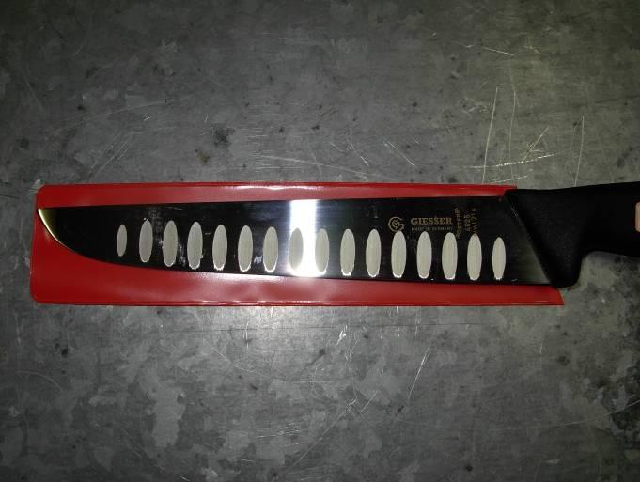
Scallops reduce drag and produce an air cushion
Picture courtesy T&R Murray Bridge South Australia

Avoiding injury when sharpening knives
To avoid injury when sharpening knives:
- when using a sharpening stone, make sure the stone is on a slip-proof, flat surface
- when using a stone, always keep your free hand away from the stone and knife. Invest in a pair of cut resistant gloves even an old pair is better than nothing
- make sure your steel has a safety guard between the handle and the body of the steel
- when using a grindstone, make sure the rotation of the stone and the cutting edge of the blade are away from your body
- if you drop your knife, let it fall, don't try to catch it
- always place your knife in the scabbard or pouch when not in use – it should not be left laying around benches and handbasins, etc.
- always use a sharp knife as you will need to use more force with a blunt knife and will have less control
- if you must look away, stop cutting – never take your eyes off the cutting path of the knife
- never cut towards yourself or towards another individual
- always be aware of the movement of people around you
- never fool around with a knife in your hand or fool around with others who may have a knife in their hand
- always keep the handle of the knife clean and free of fat and grease
- always use mesh gloves, cut resistant gloves, mesh aprons and arm guards as required in the work instructions
- take care when washing your gear at the end of the day. Many cuts have been the result of someone feeling around in the soapy water for a dropped knife. Wash them one at a time and don’t let go
- make sure when transporting knives around site they are in their pouch (no steeling while walking)
- always place knives in pouch when not in use. Do not leave knife on benches and hand basins, etc.
- dismantle pouch to ensure effective sterilisation of pouch and knives at the end of your shift.

How can knife hygiene affect food safety?
A product contact surface is something that comes in direct contact with the product you are handling. Knives are product contact surfaces.
If this surface becomes soiled or contaminated, the contamination can be carried from one product to another. This is known as cross-contamination. Both visual contamination such as grease, ingesta, hair, wool and non-visual contamination such as micro-organisms or bacteria, can be harmful to meat production.
Therefore, it is important to sterilise knives to kill harmful micro-organisms or bacteria. Knives are sterilised by immersing them in a steriliser containing hot water at a minimum of 82○C.
You should sterilise your knife:
- before starting work for the day
- after grinding, honing or steeling a knife
- if visually contaminated
- as required by workplace procedure or regulations, for example sterilising between carcases.
The scabbard should be cleaned and scrubbed every day.
Your company’s personal hygiene Standard operating procedure (SOP) will explain when and how your knife cuts and PPE should be cleaned and stored.
Knife kit and PPE should be cleaned at breaks and thoroughly cleaned and sanitised at the end of the day. The kit and PPE should be hung to dry after cleaning and sanitising at breaks and the end of work.
The way your knife kit and PPE is to be stored in your locker will also be explained in your company’s personal hygiene SOP.

How and where do you store your knife while you are working?
When you are not using your knife, always keep it in a scabbard. At present the two-piece plastic scabbard is used in most premises and is considered the easiest to keep clean.
Knives that ‘rattle’ in a pouch are losing their edge from banging against the plastic or metal. Clean rubber bands will hold them steady and in place while not being used and will also stop them falling out onto your foot or into your boot!!

How do you attach the steel and scabbard?
The chain belt worn by meat workers must be rust resistant and have a safety link. White plastic is the most common type of chain; it’s easy to clean and won’t rust. This link or snap will allow the knife kit to be pulled away safely from the worker if it becomes accidentally caught in the machinery or a fixed object.
Steels, if required for a workstation, must be carried on the worker at all times and not left in sterilisers or work benches or tucked into boot tops. The steel is hung from a chain attached to the belt. The chain must be long enough to allow freedom of movement while you are steeling but short enough so that the steel does not touch your boots. This helps prevent cross contamination: floor contacts the boots, boots contact the steel, steel contacts the knives, knives contact the product. Some premises use a steel holder attached to the belt, or place the steel through the chain belt, with no chain attached to the steel.
To avoid injury when sharpening knives:
- when using a sharpening stone, make sure the stone is on a slip-proof, flat surface
- when using a stone, always keep your free hand away from the stone and knife. Invest in a pair of cut resistant gloves even an old pair is better than nothing
- make sure your steel has a safety guard between the handle and the body of the steel
- when using a grindstone, make sure the rotation of the stone and the cutting edge of the blade are away from your body
- if you drop your knife, let it fall, don't try to catch it
- always place your knife in the scabbard or pouch when not in use – it should not be left laying around
- should not be left laying around benches and handbasins, etc.
- always use a sharp knife as you will need to use more force with a blunt knife and will have less control
- if you must look away, stop cutting – never take your eyes off the cutting path of the knife
- never cut towards yourself or towards another individual
- always be aware of the movement of people around you
- never fool around with a knife in your hand or fool around with others who may have a knife in their hand
- always keep the handle of the knife clean and free of fat and grease
- always use mesh or cut resistant gloves as required in the work instructions
- take care when washing your gear at the end of the day. Many cu
- take care when washing your gear at the end of the day. Many cuts have been the result of someone feeling around in the soapy water for a dropped knife. Wash them one at a time and don’t let go
- make sure when transporting knives around site they are in their pouch (no steeling while walking)
- always place knives in pouch when not in use. Do not leave knife on benches and hand basins, etc.
- dismantle pouch to ensure effective sterilisation of pouch and knives at the end of your shift.

Bibliography
These publications were used to develop this training material.
Agriculture and Resource Management Council of Australia and New Zealand, AS 4696:2007 Australian Standard for the hygienic production and transportation of meat and meat products for human consumption, CSIRO publishing, Collingwood, Vic.
WorkSafe – Victorian Workcover Authority: Knives in the meat and food industries - Safe use and maintenance. http://www.worksafe.vic.gov.au/wps/wcm/connect/WorkSafe/Home/

Additional resources
Registered Training Organisations (RTOs) should refer to the Unit-by-Unit listing of resources on the MINTRAC website www.mintrac.com.au for additional resources to support the delivery of this Unit.
RTOs which develop or identify additional resources are encouraged to advise MINTRAC so that these can also be added to the Unit-by-Unit listing.

